
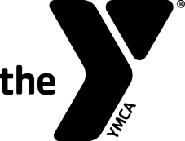
Administrative Swim Officials Training Clinic

Hosted by: Puget Sound Swimming Association (PSSA)
Date (check the class you wish to attend):
Wednesday, September 22, 2023
Thursday, November 16, 2023

Site: On-Line via Zoom
Registration Fee: For individuals affiliated with a PSSA team the cost is $-0-.

Contacts' Names Linda Vicik, lvicik@gmail.com, cell 425-653-1282
And Phones: Earl Long, ejlswim@gmail.com, cell 206-581-4688

Purpose: To certify new officials and re-certify existing officials for the YMCA of the USA's Competitive Swimming Program as Administrative Swim Officials.

Prerequisites:
- Minimum Age: 21 years old.
- Associated with a recognized YMCA Swim Team.

Registration Form

Name:_____________________ Telephone:____________________
Last 4 Digits of SSN:____________ Date of Birth:_________________
Your Address:____________________________________________
City:____________________ State:_______ Zip: _______________
Email Address: ___________________________________________
YMCA Name: _____________________________________________
YMCA Address: ___________________________________________
YMCA City, State, Zip: ______________________________________
YMCA Phone: _________________
YMCA Authorizing Signature:___________________________

