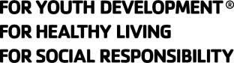
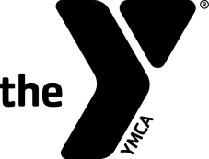
Swim Officials Level I Training Clinic

Hosted by: Puget Sound Swimming Association (PSSA)
Date (check the class you wish to attend):
Saturday, September 16, 2023
Thursday, September 28, 2023
Saturday, October 7, 2023

Site: On-Line via Zoom

Registration Fee: For individuals affiliated with a PSSA team the cost is $-0-.
The cost for those not affiliated with PSSA is $45.

Contacts' Names Earl Long, ejlswim@gmail.com, cell 206-581-4688
And Phones:

Purpose: To certify new officials and re-certify existing officials for the YMCA of the USA's Competitive Swimming Program as Level I Officials. The clinic will prepare participants to act in the capacities of Stroke and Turn Judge, Relay Take-off Judge, Place Judge and Timer.

Prerequisites: Minimum Age: 21 years old.
Associated with a recognized YMCA Swim Team.

Registration Form

Name:_____________________ Telephone:____________________
Last 4 Digits of SSN:____________ Date of Birth:_________________
Your Address:____________________________________________
City:____________________ State:_______ Zip: _______________
Email Address: ___________________________________________
YMCA Name: _____________________________________________
YMCA Address: ___________________________________________
YMCA City, State, Zip: ______________________________________
YMCA Phone: _________________
YMCA Authorizing Signature:___________________________

