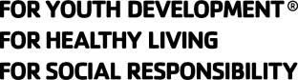
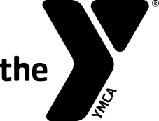
Swim Officials Level II Training Clinic

Hosted by: Puget Sound Swimming Association (PSSA)
Date (check the class you wish to attend):
Saturday, September 23, 2023
Saturday, October 21, 2023

Site: On-Line via Zoom

Registration Fee: For individuals affiliated with a PSSA team the cost is $-0-.
The cost for those not affiliated with PSSA is $45.

Contacts' Names Dave Baer, dlbaer53@gmail.com, cell 206-853-6777
And Phones: Earl Long, ejlswim@gmail.com, cell 206-581-4688

Purpose: To certify new officials and re-certify existing officials for the YMCA of the USA's Competitive Swimming Program as Level II Officials. The clinic will prepare participants to act in the capacities of Referee, Starter and Chief Judge.
Prerequisites:
- Minimum Age: 21 years old.
- Associated with a recognized YMCA Swim Team.
- For new Level II officials, have been certified for at least 1 year as a YMCA Level I Official and worked at least 8 sessions on deck as a Level I Certified Official
- For re-certification, have worked at least 12 sessions on deck as a Level II Certified Official over the previous three-year certification period.

Registration Form
Name:_____________________ Telephone:____________________
Last 4 Digits of SSN:____________ Date of Birth:_________________
Your Address:____________________________________________
City:____________________ State:_______ Zip: _______________
Email Address: ___________________________________________
YMCA Name: _____________________________________________
YMCA Address: ___________________________________________
YMCA City, State, Zip: ______________________________________
YMCA Phone: _________________
YMCA Authorizing Signature:___________________________

